2026 State of Logistics Report: Volatility is the new normal

Thomas Wasson, Tuesday, June 16, 2026
Original Article: https://www.freightwaves.com/news/2026-state-of-logistics-report-volatility-new-normal
Articles Reproduced by Permission of FreightWaves

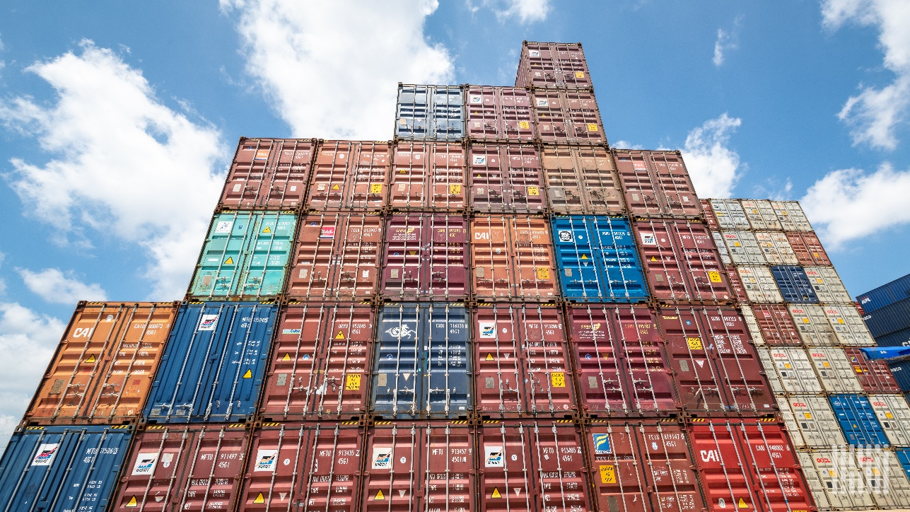
(Photo: Jim Allen/FreightWaves)

CSCMP report by Kearney and Penske details five structural forces, AI progress and sector resets that demand resilience

Supply chain volatility has moved from a temporary disruption to a permanent feature of the operating environment, according to the 2026 State of Logistics Report released Tuesday. U.S. business logistics costs totaled $2.4 trillion last year, or 7.8% of gross domestic product, down from $2.6 trillion and 8.7% of GDP in 2025.

The report, authored by Kearney and presented by Penske Logistics for the Council of Supply Chain Management Professionals, identifies five structural forces that continue to reshape the macro environment. These include asymmetrical global growth, tightening financial conditions, geoeconomic realignment, labor and productivity constraints, and energy price volatility.

Regional growth remains uneven, with the United States, India and Southeast Asia outperforming Europe and Gulf economies. Disruptions at the Strait of Hormuz and frequent tariff changes add ongoing pressure to trade lanes.

For carriers and shippers, the findings represent more than another difficult year. Traditional drivers of performance such as demand recovery and network scale are becoming less reliable. Success now depends more on building resilience into operations. This includes maintaining pricing discipline, and accelerating investments in digital tools and automation. The goal is to deliver measurable returns under volatile conditions.

Artificial intelligence has crossed from evaluation into commercial application in targeted areas. The report notes progress in using AI to interpret network signals, predict disruptions, recommend actions and execute workflows. Physical automation in warehouses and transportation are showing early commercial milestones. Adoption remains uneven, however, widening the gap between companies embedding AI into core operations and those still limited to isolated point solutions.

Five structural forces define the macro outlook
The report identifies five persistent structural forces showing no signs of resolution: asymmetrical global growth, tightening financial conditions driven by persistent inflation and rising public debt, accelerating trade flow and geoeconomic realignment, labor market and productivity constraints and energy price volatility.

The report notes a divergence in regional growth across the globe. The United States projects 2.2 percent to 2.4 percent growth for 2026, while India and Southeast Asia lead expansion. Europe lags at roughly 1 percent. GCC economies have turned negative, contracting 1.2 percent as the Middle East conflict disrupts energy flows.

The Strait of Hormuz has emerged as a defining chokepoint, carrying 20 million barrels of oil per day and 20 percent of global liquefied natural gas trade. Tariff policy was another major factor. It changed on average every 1.5 weeks in 2025, creating what the report calls a “paralysis effect” on network reconfiguration decisions.

AI crosses from trial to measurable returns
Artificial intelligence has evolved beyond trials and reached a genuine turning point in logistics. It is no longer an experimental technology. Instead, it is now delivering measurable commercial returns in specific, well-defined applications.

The report frames AI value creation through four capabilities: interpret, predict, recommend and execute. Interpret and predict are the most mature, built on years of investment in visibility platforms and telematics. Physical AI, covering warehouse robotics and autonomous vehicles, is producing some of the industry’s most visible commercial milestones.

Adoption remains uneven, widening the gap between organizations that have embedded AI into core workflows and those still confined to isolated point solutions.

Freight sector divergence intensifies
Air freight posted record cargo volumes in 2025 with global demand up 3.4 percent, but corridor-level results told the real tale. Asia-Europe surged 10.3 percent as shippers rerouted around disruptions while Asia-North America slipped 0.8 percent. Early 2026 showed acceleration, but rising fuel costs, sustainable aviation fuel requirements and geopolitical routing constraints are adding volatility. The market is shifting toward value-dense cargo where speed and reliability matter more than pure freight cost.

The U.S. parcel and last-mile sector has undergone a structural reset, not post-pandemic normalization. Removal of de minimis treatment for China-origin parcels cut daily volumes by about 85 percent, pushing volume toward domestic fulfillment. Carrier costs have reset with general rate increases around 5.9 percent plus fuel and accessorial surcharges. Demand remains supported by more than $1.23 trillion in U.S. e-commerce but has split into a barbell: ultra-low-cost regional delivery on one end and premium-speed service on the other. Platform-controlled routing is shifting advantage from network ownership to intelligence and integration.

The third-party logistics (3PL) sector sits at a strategic inflection point. Shippers are moving from transactional execution to end-to-end orchestration amid regulatory complexity, tariff volatility and cross-border shifts. Leading providers are responding by expanding scale and node density. They are embedding real-time visibility and deploying AI to manage cost without proportional headcount growth. Winners are evolving toward integrated, 4PL-like solutions.

Freight forwarding entered 2026 in structural reset. Margin discipline is the priority amid persistent overcapacity in ocean despite stabilizing volumes. Geopolitical disruption has become continuous rather than episodic. Value is migrating from traditional brokerage margins toward higher-value services such as customs, compliance, warehousing and supply chain financing, supported by technology-enabled solutions.

Ocean freight remains structurally oversupplied even as disruptions reduce effective capacity. Fleet growth outpaced demand in 2025, and a wave of new-build capacity entering in 2026 is deepening the imbalance. Multiple chokepoints, including the Red Sea, Strait of Hormuz, Panama Canal and Black Sea, have provided short-term rate support while limiting alternatives. For shippers, the soft market creates a procurement window, but volatility rewards contract flexibility and scenario planning over attempts to time the market.

Strategic takeaways for what lies ahead
Mark Baxa, president and chief executive officer of the Council of Supply Chain Management Professionals, summed it up: “The supply chain of right now is incredibly complex and requires a series of constant adjustments. Last year’s supply chain looks different than today’s supply chain. I surmise that next year’s logistics network will be hardly recognizable.”

The report lays out five strategic implications: Design networks for resilience, not just efficiency; prioritize asset productivity over footprint expansion; embed trade compliance and geopolitical intelligence as competitive capabilities; accelerate digital and automation ROI; and reassess capital structure and investment pacing with emphasis on shorter, measurable payback periods.

“This year’s report arrives at a moment when the forces reshaping global supply chains are no longer temporary disruptions, but enduring features of the operating environment,” said Korhan Acar, a Kearney partner and lead author of the report. “Rising costs driven by energy volatility, inflation and geopolitical instability are placing pressure on margins and forcing leaders to rethink traditional operating models. At the same time, we have reached a genuine turning point in the autonomous era. The companies that will lead are those combining resilience, intelligent logistics and disciplined execution to protect margins and outperform in an increasingly volatile world.”

